

Inclusive Retail Service Guide
These practices support guests with sensory sensitivities — including autism, ADHD, PTSD, anxiety, and sensory processing differences.

5 Basics for Calm Service
These small changes lower stress for guests and help your shift run smoother.
- One voice at a time — too many sounds can overwhelm.
- Slow your words and pace. Calm tone builds trust.
- Offer one choice (A or B). Simpler is smoother.
- Respect breaks — stepping away is regulation, not rudeness.
- Use visuals or gestures when possible (point, show, tap).

What You Can Say
Use calm, simple language — it keeps everyone grounded and respected.
Situation | Say this calmly
Customer covers ears / looks anxious | “It’s okay, we can turn that down.”
Child hiding or pacing | “You’re safe here. Take your time.”
Parent looks tense or apologizes | “You’re doing great — no rush.”
Loud moment or meltdown nearby | “Let’s give them some space.”

Common Scenarios
You can’t fix every moment — but kindness and small adjustments can make someone’s day.
Scenario | What to Do
Loud Music / Overhead Announcements | Lower volume briefly or turn off speaker near sensory-sensitive guests.
Crowded Aisle | Offer another route: “You can go around this way if that’s easier.”
Register Beeps / Scanners | Mute or turn volume down when possible.
Line Stress | “Want to step aside and come back when ready?”
Unexpected Touch | Use verbal prompts — guests respond best when given space.

Why It Matters
1 in 6 people experience sensory sensitivities that affect how they engage in public spaces. Calm, inclusive service supports both guests and staff — reducing stress and building confidence. Inclusive practices improve guest satisfaction, repeat visits, and team morale.
If you only remember one thing: Lower the input—sound, light, crowding—and speak slowly with one clear choice.

Thank you for making inclusive service part of your store culture.

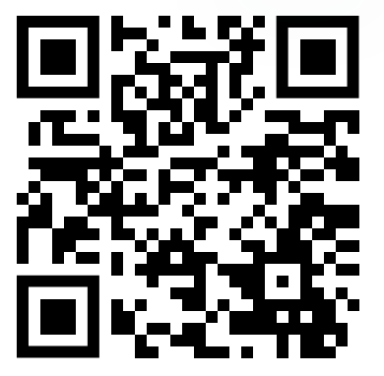
Download and Customize (free)
Scan to get English/Español versions or to print more:
Short URL: qr.link/wVPOF6
Disclaimer: Educational resource; not medical advice; caregiver supervision required. Venue remains responsible for care and safety.

